**Project Design Phase**

**Solution Architecture**

|  |  |
| --- | --- |
| Date | 13 June 2025 |
| Team ID | LTVIP2025TMID60014 |
| Project Name | Health ai: intelligent healthcare assistant using ibm granite |
| Maximum Marks | 4 Marks |

**Solution Architecture**

Solution architecture is a critical process that connects the healthcare challenges faced by users with appropriate AI-powered technical solutions. For **Health AI**, this architecture bridges real-world medical information needs and the capabilities of IBM Granite-based generative AI.

Its goals in this project are to:

* **Identify and apply the most effective AI technologies** (like IBM Granite 13b-instruct-v2) to support healthcare needs such as symptom evaluation, treatment guidance, and health analytics.
* **Design a modular system architecture** using components like Stream lit frontend, Hugging Face model APIs, and secure backend logic to ensure scalability, accessibility, and accuracy.
* **Define the structure and flow** of user interaction — from input (symptom/question) to model inference to response — in a way that's intuitive, fast, and user-friendly.
* **Specify development phases** clearly: starting from basic chat support and diagnosis suggestions to future features like real-time health analytics and wearable integration.
* **Ensure responsible delivery** by incorporating secure token management, clear medical disclaimers, and non-diagnostic positioning while offering high-quality AI responses.

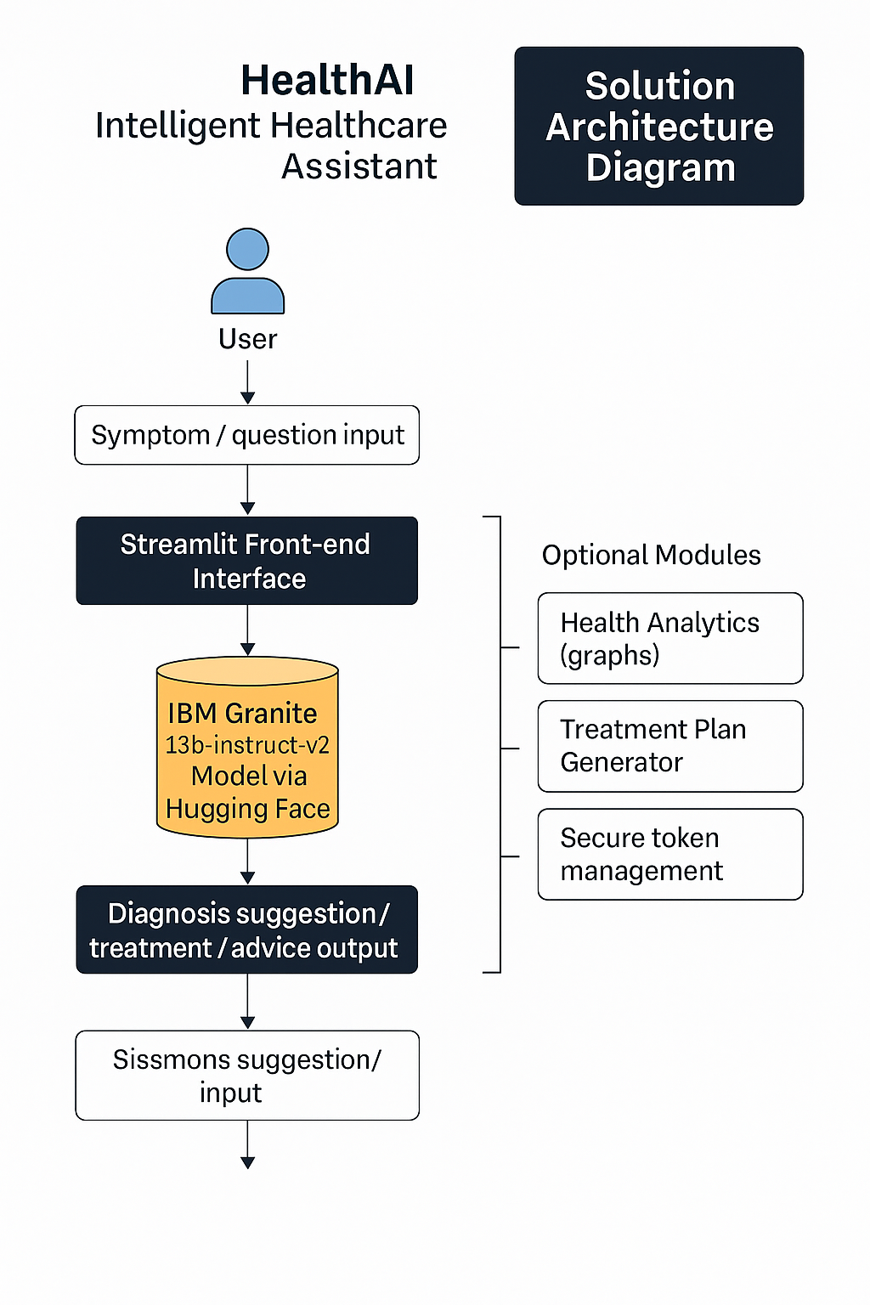**Example - Solution Architecture Diagram:**

*Figure 1: Architecture and data flow of the voice patient diary sample application*